**SAPPHIRE INVERTER CEILING FANS:**

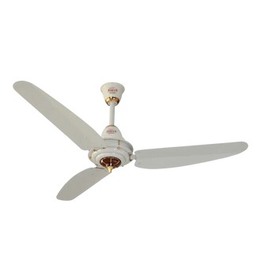

**Price: 14,495.00**

Sapphire Inverter Ceiling Fans represent the pinnacle of innovative cooling technology. These sleek and modern fans boast advanced inverter motors that optimize energy efficiency, reducing power consumption by up to 50%. With their whisper-quiet operation, variable speed control, and reversible functionality, Sapphire Inverter Ceiling Fans provide unparalleled comfort and flexibility. Their durable construction, rust-resistant coating, and stylish designs ensure a long-lasting and visually appealing addition to any room. Whether for residential or commercial spaces, Sapphire Inverter Ceiling Fans offer a perfect blend of style, substance, and sustainability.

**Key features of sapphire inverter ceiling fans include:**

* **Inverter Technology:** Ensures energy efficiency and silent operation.
* **Remote Control:** Convenient control of speed and settings from a distance.
* **Multiple Speed Options:** Adjustable settings for personalized airflow.
* **Durable Construction:** High-quality materials for longevity.
* **Reversible Motor:** Allows for both summer and winter air circulation.
* **Modern Design:** A sleek and stylish look for various interiors.
* **Energy Saving:** Low power consumption for reduced electricity bill.

Top of FormBottom of Form